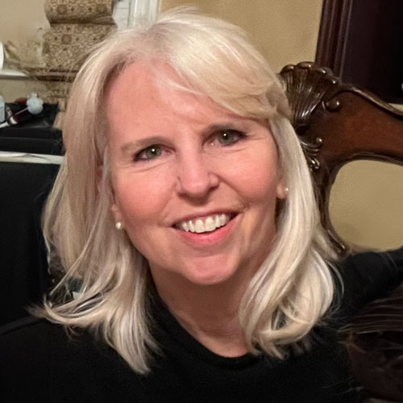

**Amy Castoro**

*President and Chief Executive Officer  
The Williams Group*

Amy Castoro is a recognized expert in preparing high-net-worth families to successfully transition wealth while maintaining family unity and control over assets. As President and CEO of The Williams Group, she leads a team dedicated to ensuring the smooth transfer of wealth across generations. Amy is also an accomplished author, keynote speaker, and senior family coach known for her direct yet compassionate approach, which fosters long-term relationships and delivers measurable results.

With over two decades of experience guiding high-performing individuals and teams, Amy excels at building trust quickly, coordinating effectively, and cultivating resilient relationships. Her unique skill set makes her especially equipped to support family members, wealth advisors, business leaders, and executive teams in leading, innovating, and working more collaboratively. Her corporate experience includes The Walt Disney Company, Adecco Corporation, and Grant Thornton Management Consulting.

Amy is the author of *Bridging Generations—Transitioning Family Wealth and Values for a Sustainable Legacy*. She also contributed the chapter “Ladies, Take a Seat” to *Stepping into Your Power: An Embodied Approach to Developing Women Leaders*. Her thought leadership is regularly featured in prominent publications such as *Harvard Business Review*, *The Wall Street Journal*, *The New York Times*, *Financial Times*, *CNN Money*, *Forbes*, *Family Wealth Report*, and the *Journal of Wealth Management*. She is also a frequent podcast guest, including on *Motley Fool’s Rule Breaker Investing*, where one of her episodes was ranked among the show’s top ten.

Amy holds a Bachelor's degree in Organizational Psychology from Adelphi University and a Master’s in Somatic Coaching from the Strozzi Institute.